SIMATS ENGINEERING
ASSESSMENT TOOL 1
COURSE NAME: Artificial Intelligence COURSE CODE: CSA17
COURSE OUTCOME COVERED

CO1: Apply AI basics such as intelligent agents and uninformed search methods to solve problems effectively. (BL3)

Assessment Tool Weightage: 50%
QUESTIONS: 5 Duration : 1 Hour
Total Marks:50

Annexure A
Analytical Problem Solving

Code of Conduct:
I RISHIK JK 192511052 certify that this submission is my original work
and that I have adhered to the guidelines specified for this assessment.
I understand that any violation of academic integrity rules will result in disciplinary action.
Signature of the student:RISHIK JK

Annexure A
Analytical Problem Solving

1. Solve the Water Jug problem: you are given 2 jugs, a 4-gallon one and 3-gallon one.
Neither has any measuring maker on it. There is a pump that can be used to fill the
jugs with water. How can you get exactly 2 gallons of water into 4-gallon jug?
Explicit assumptions: A jug can be filled from the pump, water can be poured out of a
jug onto the ground, water can be poured from one jug to another and that there are
no other measuring devices available.

2. Find out how Mars Rover, analyse and explore the samples on Mars by answering the
following questions.
i. What are the percept’s for this agent?
ii. Characterize the operating environment.
iii. What are the actions the agent can take?
iv. How can one evaluate the performance of the agent?
v. What sort of agent architecture do you think is most suitable for this agent?
Why?

3. Explore the search space using search strategies and formulate the problem
components for the 8-Queens problem using the following information: Place 8
queens on a chessboard such that none of the queen’s attack any of the others. A
configuration of 8 queens on the board as shown in the figure below, but this does not
represent a solution as the queen in the first column is on the same diagonal as the queen in the last column.
4. A customer wants to travel from the one location to another location using OLA Cab
booking mobile application. The customer can select the any of the cab type as mini,
micro, sedan, shared, prime and so on based on his comfort to reach the destination.
Identify what type of problem-solving agent can be used and write the pseudocode
for the above problem.

5. A logistics company operates a delivery network where packages must be transported
between warehouses at minimum cost. Each route between warehouses has an
associated travel cost (fuel + time). The company wants to determine the least-cost
path from the starting warehouse S to the destination warehouse G using the Uniform
Cost Search (UCS) algorithm.
The delivery network is represented as a weighted graph:

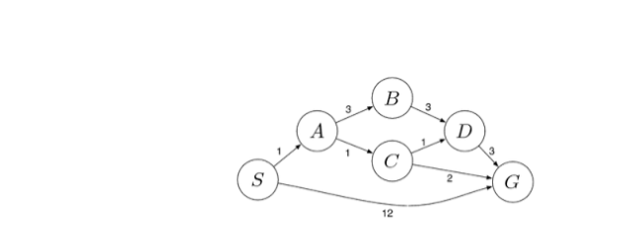

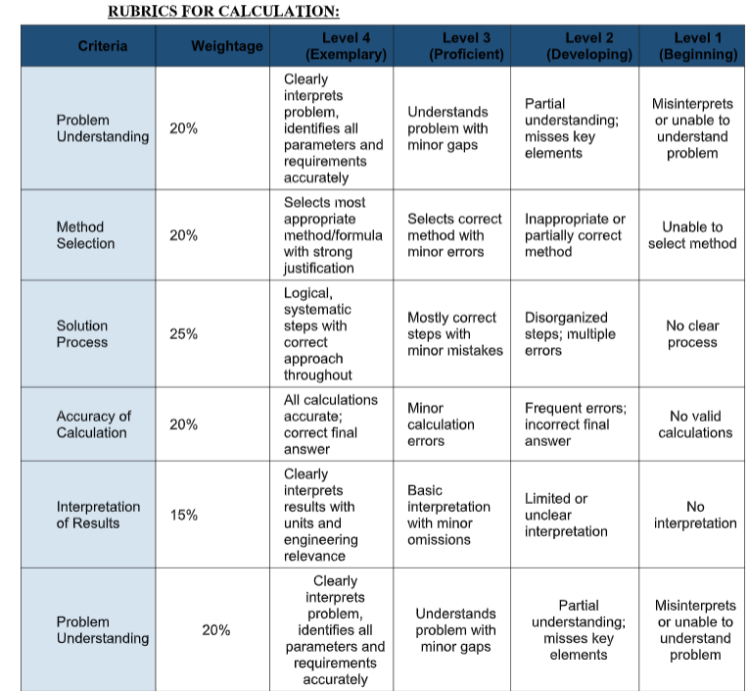

QUESTION 1: WATER JUG PROBLEM

Problem Statement
Two jugs are given with capacities of 4 gallons and 3 gallons. Neither jug has measuring markings. A water pump is available to fill the jugs. Water can be emptied onto the ground or transferred between the jugs. The objective is to obtain exactly 2 gallons of water in the 4-gallon jug.

Aim
To obtain exactly 2 gallons of water in the 4-gallon jug using the State Space Search technique.

Given Data
- Jug A capacity = 4 gallons
- Jug B capacity = 3 gallons
- Initial State = (0, 0)
- Goal State = (2, 0)

Method Used: State Space Search
State Space Search is an Artificial Intelligence problem-solving technique used to find a sequence of valid operations from an initial state to a goal state.
Each state is represented as (A, B), where A represents the amount of water in the 4-gallon jug and B represents the amount in the 3-gallon jug.
The allowed operations are filling a jug, emptying a jug and transferring water between the jugs.

Step-by-Step Solution
Step 1: Initially, both jugs are empty.
State: (0, 0)
Step 2: Fill the 3-gallon jug completely using the water pump.
State: (0, 3)
Step 3: Pour all 3 gallons of water into the 4-gallon jug.
State: (3, 0)
Step 4: Fill the 3-gallon jug again.
State: (3, 3)
Step 5: Pour water from the 3-gallon jug into the 4-gallon jug until the 4-gallon jug becomes full. Since the 4-gallon jug already contains 3 gallons, only 1 gallon is transferred. Therefore, 2 gallons remain in the 3-gallon jug.
State: (4, 2)
Step 6: Empty the 4-gallon jug completely onto the ground.
State: (0, 2)
Step 7: Transfer the remaining 2 gallons from the 3-gallon jug into the 4-gallon jug.
State: (2, 0)

State Space Representation
(0, 0) → (0, 3) → (3, 0) → (3, 3) → (4, 2) → (0, 2) → (2, 0)

Result
Exactly 2 gallons of water are successfully obtained in the 4-gallon jug without using any measuring device.

Conclusion
The Water Jug Problem is successfully solved using State Space Search by performing a sequence of filling, emptying and pouring operations. This demonstrates how Artificial Intelligence problem-solving techniques can achieve a specific goal through valid actions.

QUESTION 2: MARS ROVER – INTELLIGENT AGENT

Problem Statement
Find out how a Mars Rover analyzes and explores samples on Mars by answering the following questions:
i. What are the percepts for this agent?
ii. Characterize the operating environment.
iii. What are the actions the agent can take?
iv. How can one evaluate the performance of the agent?
v. What sort of agent architecture is most suitable for this agent? Why?

Introduction
A Mars Rover is a robotic vehicle designed to explore the surface of Mars. It uses cameras, sensors and scientific instruments to observe its surroundings, collect rock and soil samples, and perform scientific experiments. In Artificial Intelligence, the Mars Rover acts as an intelligent agent because it receives information from its environment and takes suitable actions to achieve its goals.

i. What Are the Percepts for This Agent?
Percepts are the information received by an intelligent agent through its sensors.
The main percepts of a Mars Rover are:
Camera Images: Capture images of rocks, soil and the surrounding environment.
Distance Measurements: Detect obstacles and identify safe paths.
Temperature Readings: Measure the temperature of the Martian surface.
Rock and Soil Data: Collect information about the chemical composition of samples.
Position and Direction: Identify the rover's movement, position and orientation.
Power Status: Monitor battery levels and the condition of onboard equipment.

ii. Characterize the Operating Environment
The operating environment of a Mars Rover has the following characteristics:
Partially Observable: The rover cannot observe the entire environment at once because its sensors have limited range.
Stochastic: The results of its actions may be uncertain due to rocks, loose soil and uneven surfaces.
Sequential: Each action affects future decisions and movements.
Dynamic: Environmental conditions such as dust, wind and temperature can change.
Continuous: Measurements such as distance, speed, position and time have continuous values.
Single-Agent: The rover mainly performs its exploration tasks independently.
Unknown Environment: The rover may encounter unfamiliar locations and obstacles during exploration.

iii. What Are the Actions the Agent Can Take?
The Mars Rover can perform the following actions:
Move forward, backward, left and right.
Detect and avoid obstacles while navigating.
Capture photographs of the Martian surface.
Collect rock and soil samples using robotic tools.
Analyze samples using scientific instruments.
Send images and scientific data to Earth.
Select alternative routes when obstacles are detected.
Monitor battery power and perform system checks.

iv. How Can One Evaluate the Performance of the Agent?
The performance of a Mars Rover can be evaluated based on the following factors
Scientific Accuracy: The quality and accuracy of scientific information collected.
Navigation Efficiency: The ability to reach target locations safely and efficiently.
Sample Collection: Successful collection and analysis of rock and soil samples.
Safety: The ability to avoid obstacles and prevent equipment damage.
Energy Efficiency: Effective use of available battery power.
Mission Success: Successful completion of exploration and research objectives.A Mars Rover is considered successful when it collects useful scientific data, navigates safely and completes its assigned mission objectives.

v. What Sort of Agent Architecture Is Most Suitable for This Agent? Why?
Suitable Agent Architecture: Model-Based Goal-Based Agent with Learning Capabilities
A model-based goal-based agent with learning capabilities is suitable for a Mars Rover because it must make decisions in an unfamiliar and partially observable environment.

Reasons:
A model-based agent maintains information about the environment using previous observations.
A goal-based agent plans suitable actions to reach specific exploration targets.
Learning capabilities help the rover improve its decisions using previous experiences.
The rover can identify obstacles and plan alternative routes.
It can perform certain tasks autonomously when communication with Earth is delayed.
This architecture supports safer navigation and efficient scientific exploration.
Therefore, a combination of model-based reasoning, goal-based planning and learning capabilities is suitable for Mars Rover exploration.

Result
The Mars Rover is analyzed as an intelligent agent that receives percepts through sensors and performs actions using robotic tools. Its operating environment is partially observable, uncertain and sequential. A model-based goal-based architecture with learning capabilities is suitable for achieving safe and efficient exploration.

Conclusion
The Mars Rover demonstrates the application of Artificial Intelligence in space exploration. By using sensors, autonomous navigation, scientific instruments and intelligent decision-making, it can explore Mars, collect samples and perform scientific experiments efficiently.

QUESTION 3: 8-QUEENS PROBLEM

Aim
To place 8 queens on an 8×8 chessboard so that no two queens attack each other using a search strategy.

Problem Formulation
Initial State: An empty 8×8 chessboard.
State Space: All possible arrangements of queens on the chessboard.
Actions: Place one queen in a safe position in each column.
Goal Test: All 8 queens are placed without attacking each other.
Path Cost: Each queen placement has a cost of 1.

Search Strategy: Backtracking
Backtracking is a search technique that places queens one by one. If a queen cannot be placed safely, the algorithm returns to the previous position and tries another location.

Solution Steps
Start with an empty chessboard.
- Place the first queen in the first column.
- Move to the next column and find a safe row.
- Check that no two queens share the same row or diagonal.
- If no safe position exists, backtrack and change the previous queen's position.
- Repeat until all 8 queens are placed safely.

Valid Queen Positions
(Row, Column):
(1,1), (5,2), (8,3), (6,4), (3,5), (7,6), (2,7), (4,8)

Result
All 8 queens are successfully placed on the chessboard without attacking each other.

Conclusion
The 8-Queens Problem is solved using Backtracking Search, which explores possible positions and removes invalid arrangements.

QUESTION 4: OLA CAB BOOKING – PROBLEM-SOLVING AGENT

Aim
To identify a suitable problem-solving agent for the OLA Cab Booking application and write its pseudocode.

Problem Statement
A customer wants to travel from one location to another using the OLA Cab application. The customer can choose Mini, Micro, Sedan, Shared or Prime based on comfort, cost and availability.

Type of Agent: Utility-Based Agent
A Utility-Based Agent is suitable because it selects the best option based on user preferences such as price, comfort and travel time.

Working Procedure
- The customer enters the pickup and destination locations.
- The application displays available cab types.
- The customer selects a cab based on comfort and budget.
- The system checks cab availability and estimated fare.
- The application books the selected cab.
- The driver picks up the customer and completes the trip.

Pseudocode

START
INPUT pickup_location
INPUT destination_location
INPUT budget
INPUT comfort_preference
DISPLAY available cab types
(Micro, Mini, Sedan, Shared, Prime)
FOR each available cab
CHECK fare, comfort and travel time

IF fare <= budget THEN
CALCULATE utility score based on
comfort, fare and travel time
END IF
END FOR
SELECT cab with highest utility score
IF suitable cab is available THEN
CONFIRM booking
DISPLAY cab and driver details
ELSE
DISPLAY "No suitable cab available"
END IF
STOP

Result
The Utility-Based Agent helps the customer select a suitable cab based on cost, comfort, travel time and availability.

Conclusion
The OLA Cab Booking application can use a Utility-Based Agent to compare available cab options and support efficient travel decisions.

QUESTION 5: UNIFORM COST SEARCH (UCS)

Aim
To find the least-cost path from the starting warehouse S to the destination warehouse G using the Uniform Cost Search algorithm.

Problem Statement
A logistics company transports packages between warehouses. Each route has a travel cost based on fuel and time. The objective is to identify the route with the minimum total cost.

Method Used: Uniform Cost Search
Uniform Cost Search is an uninformed search algorithm that always expands the node with the lowest cumulative path cost.
It uses a priority queue to select the least-cost path.

Algorithm
- Start from warehouse S with a cost of 0.
- Insert S into the priority queue.
- Select the node with the lowest cumulative cost.
- Explore its neighboring warehouses.
- Calculate the new cost by adding the route cost.
- Update the path if a lower cost is found.
- Repeat until destination G is selected for expansion.

Pseudocode
START
INSERT S into priority queue with cost 0
WHILE priority queue is not empty:
REMOVE node with minimum path cost

IF node = G:

DISPLAY minimum cost and path

STOP

FOR each neighboring warehouse:

CALCULATE new_cost = current_cost + edge_cost

IF new_cost is lower than recorded cost:

UPDATE cost and path

INSERT neighbor into priority queue
END WHILE
DISPLAY "No path found"
STOP

Result
Uniform Cost Search identifies a least-cost route from warehouse S to warehouse G by comparing cumulative travel costs.

Conclusion

UCS helps logistics companies reduce transportation costs by selecting the minimum-cost delivery route when all route costs are non-negative.

